Intern Task Document

Task-1

Project Title: Create a Personal Portfolio Page

Skill Focus: HTML, CSS, Bootstrap

🧩 Task Objective
Design and build a Personal Portfolio Website using semantic HTML, custom CSS styling, and Bootstrap components. This page should effectively showcase personal information, project work, and provide a way for users to get in touch.

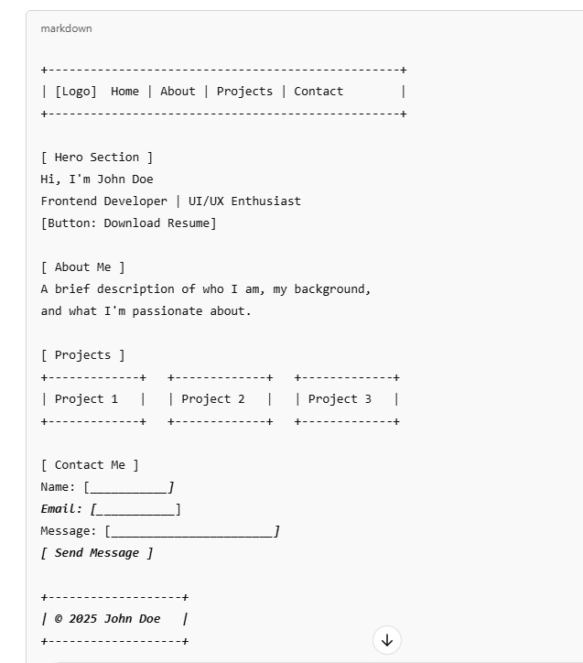

Tools & Technologies
- HTML: Semantic tags (<header>, <section>, <article>, <footer>, etc.)
- CSS: Custom styling for colors, fonts, spacing, responsiveness
- Bootstrap 5: Navbar, grid system, cards, buttons, form components

Step-by-Step Roadmap.

Phase 1: Planning
- Define your personal brand (name, title, short bio)
- Decide on 3–4 projects to showcase (can be placeholders)
- Choose color palette and fonts (Google Fonts is acceptable)

Phase 2: HTML Structure
- Set up base layout using semantic HTML5 tags
- Create sections:
  - Header/Navbar (Logo + links)
  - Hero Section (Intro + call-to-action)
  - About Me (Text content)
  - Projects (Three sample cards or boxes)
  - Contact Form (Basic inputs + button)
  - Footer (Copyright)

Phase 3: Bootstrap Integration
- Use Bootstrap 5’s Navbar component
- Apply Grid system for project layout
- Use Card components for projects
- Style form using Bootstrap’s Form controls
- Add responsive behavior to all sections

Phase 4: Custom CSS Styling
- Override Bootstrap styles for personalized design
- Add hover effects, transitions for buttons and cards
- Use media queries if needed for fine-tuned responsiveness

Phase 5: Final Touches
- Add favicon and title in <head>
- Ensure all sections are well-aligned and responsive
- Include a Download Resume button (use a dummy link or Google Drive)
- Test on different screen sizes

🧪 Checklist Before Submission
- Navbar with scrollable links
- Hero section with heading and call-to-action
- “About Me” section written in own words
- Project cards aligned in a responsive layout
- Fully styled contact form with submit button
- Footer with working social/profile links
- Uses both custom CSS and Bootstrap components
- Mobile and tablet responsive
- All links and buttons functional

Task-2

Project Title: Product Landing Page with Login & Signup

Skill Focus: HTML, CSS, Bootstrap

🧩 Task Objective
Design and build a modern, responsive Product Landing Page featuring at least three products, a navigation bar, and dedicated login/signup forms. The layout must be clean, interactive, and mobile-friendly using a combination of HTML, CSS, and Bootstrap.

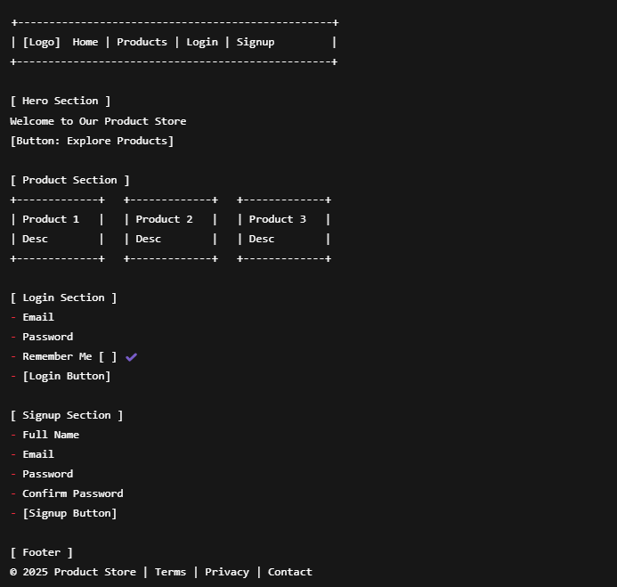

Tools & Technologies
- HTML: Structure the page using semantic tags and clean layout practices.
- CSS: Use transitions, hover effects, responsive layout with media queries.
- Bootstrap 5: Use pre-built Navbar, Card, Grid, Form, and Button components.
Step-by-Step Roadmap

Phase 1: Layout Planning
- Choose product types or use placeholders (e.g., books, gadgets, courses)
- Plan navigation flow: Home → Products → Login → Signup
- Decide on section content (titles, descriptions, labels)

Phase 2: HTML Page Structure
- Create base layout with:
  - Navbar (with navigation links)
  - Hero Section (welcome message and CTA)
  - Product Cards Section (minimum 3)
  - Login Section (simple form)
  - Signup Section (registration form)
  - Footer (links and legal info)

Phase 3: Bootstrap Integration
- Use Navbar component with responsive toggler
- Build Card components for each product using Bootstrap grid
- Use Forms with Bootstrap form groups for Login and Signup
- Layout form sections using container, row, and col

Phase 4: CSS Styling & Interactivity
- Apply hover effects on product cards and buttons
- Use media queries to adjust layout for mobile/tablet
- Add subtle animations or transitions (e.g., fade-in, scale on hover)
- Override Bootstrap styles to personalize the page (optional)

Phase 5: Testing & Final Review
- Ensure navigation works (jump to section or modal)
- Forms should be aligned and styled properly
- Page should work well on desktops, tablets, and phones
- All UI elements should be visually consistent and clean

✅ Checklist Before Submission
- Navbar with responsive toggler
- Hero section with a short welcome message and CTA
- At least 3 product cards with descriptions
- Login form with email, password, checkbox
- Signup form with full name, email, password
- Forms styled with Bootstrap components
- Custom hover effects and transitions applied
- Responsive layout on all screen sizes
- Footer with appropriate links and branding

